**1 - Monthly Compiler**  
(For Compiling workbooks with same column headings)  
  
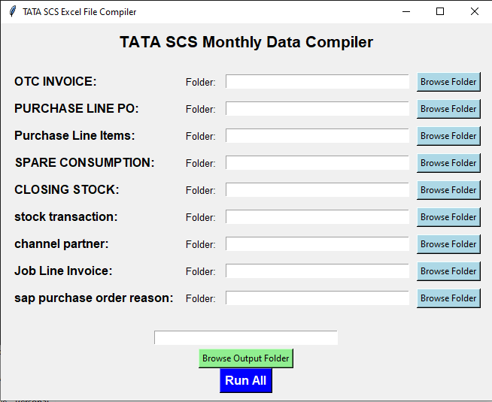

Here we have to put the path of folder we want the compiled workbooks. (copy paste the path or use the browse output folder button to select the folder)

Here we have to give the path of folders the workbooks are in, have to put correct folder path besides correct file name you want so it can be saved with that particular name.

**(copy paste the path or use the browse output folder button to select the folder)**

**2 - Compiler**

(for combining workbooks with same headings to 1 Workbook)

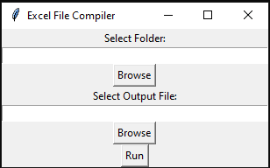

Here we have to give the path of folders where we want the output

Here we have to give the path of folders the workbooks are in

**Note: When selecting for the output folder path we have to manually type the name we want for the compiled Workbook.**

Can use the same folder as input folder.

For example:   
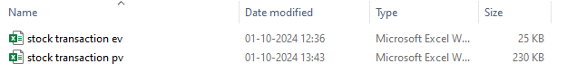

We need these files as compiled so we select these files folder path and give a path for output folder  
and type the name as stock transaction compiled.  
  


It will give us this output.`

**3 - Po Upload**

(Single & Multiple Po file compile & make as per logic CV & PV and give output with location wise for upload.)

